Learn-In-Depth

Report Lab1

Eng: Amer Khaled

Main.c

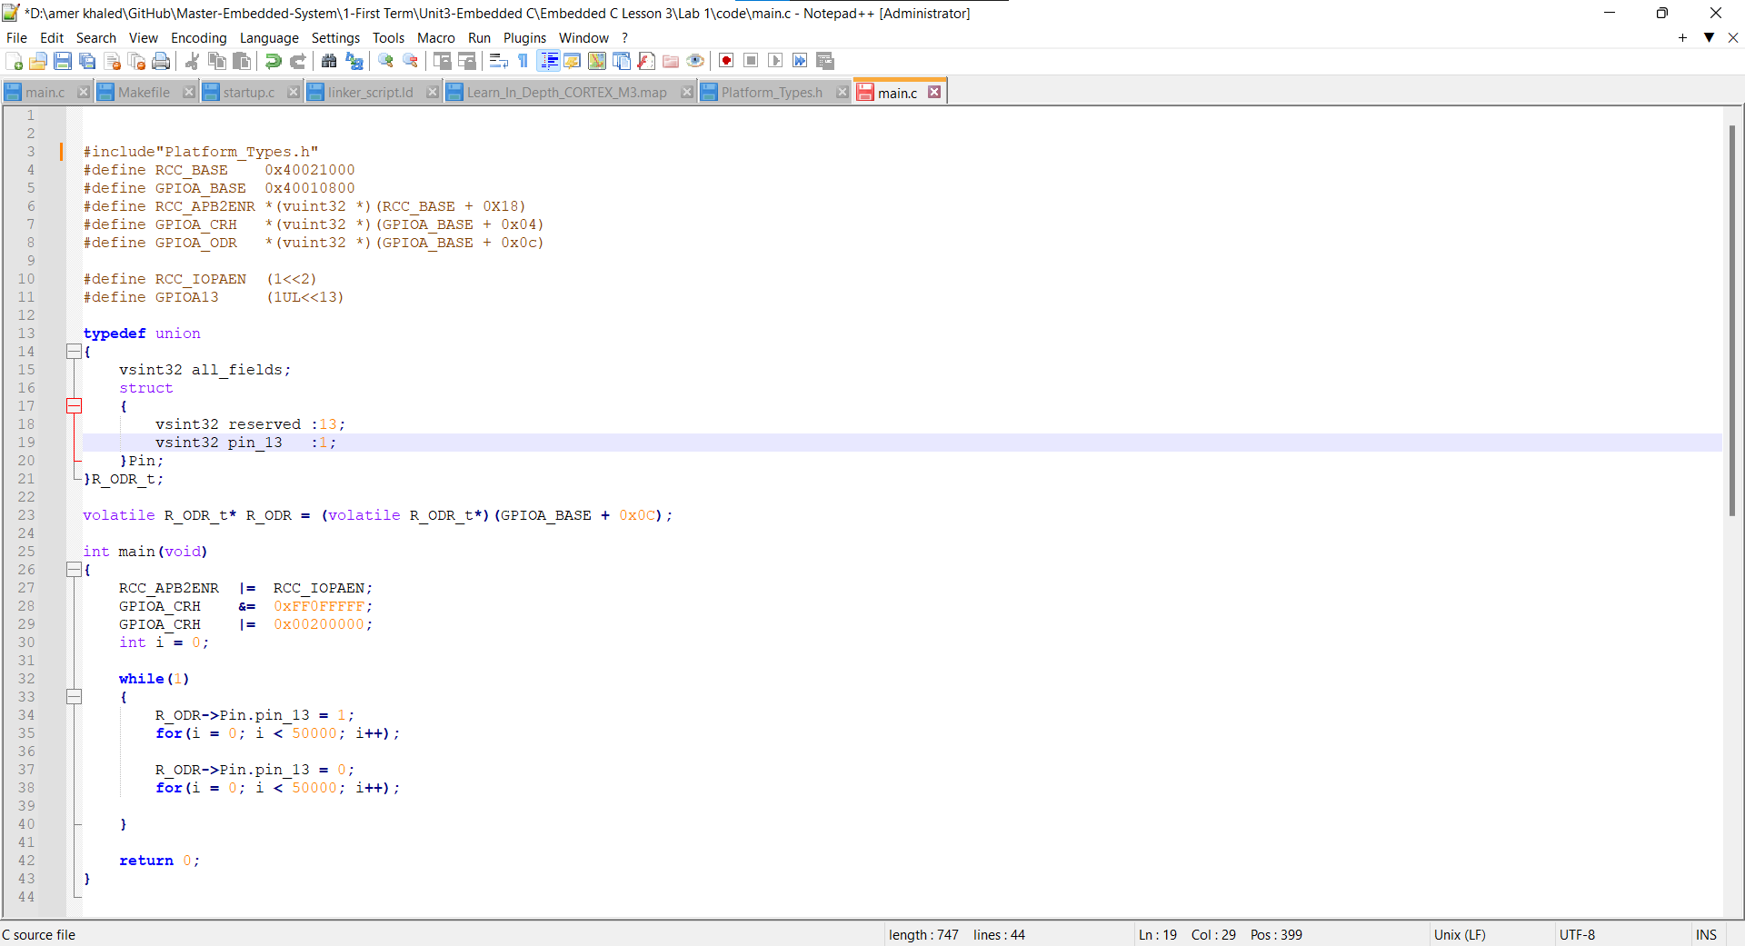

Startup.s

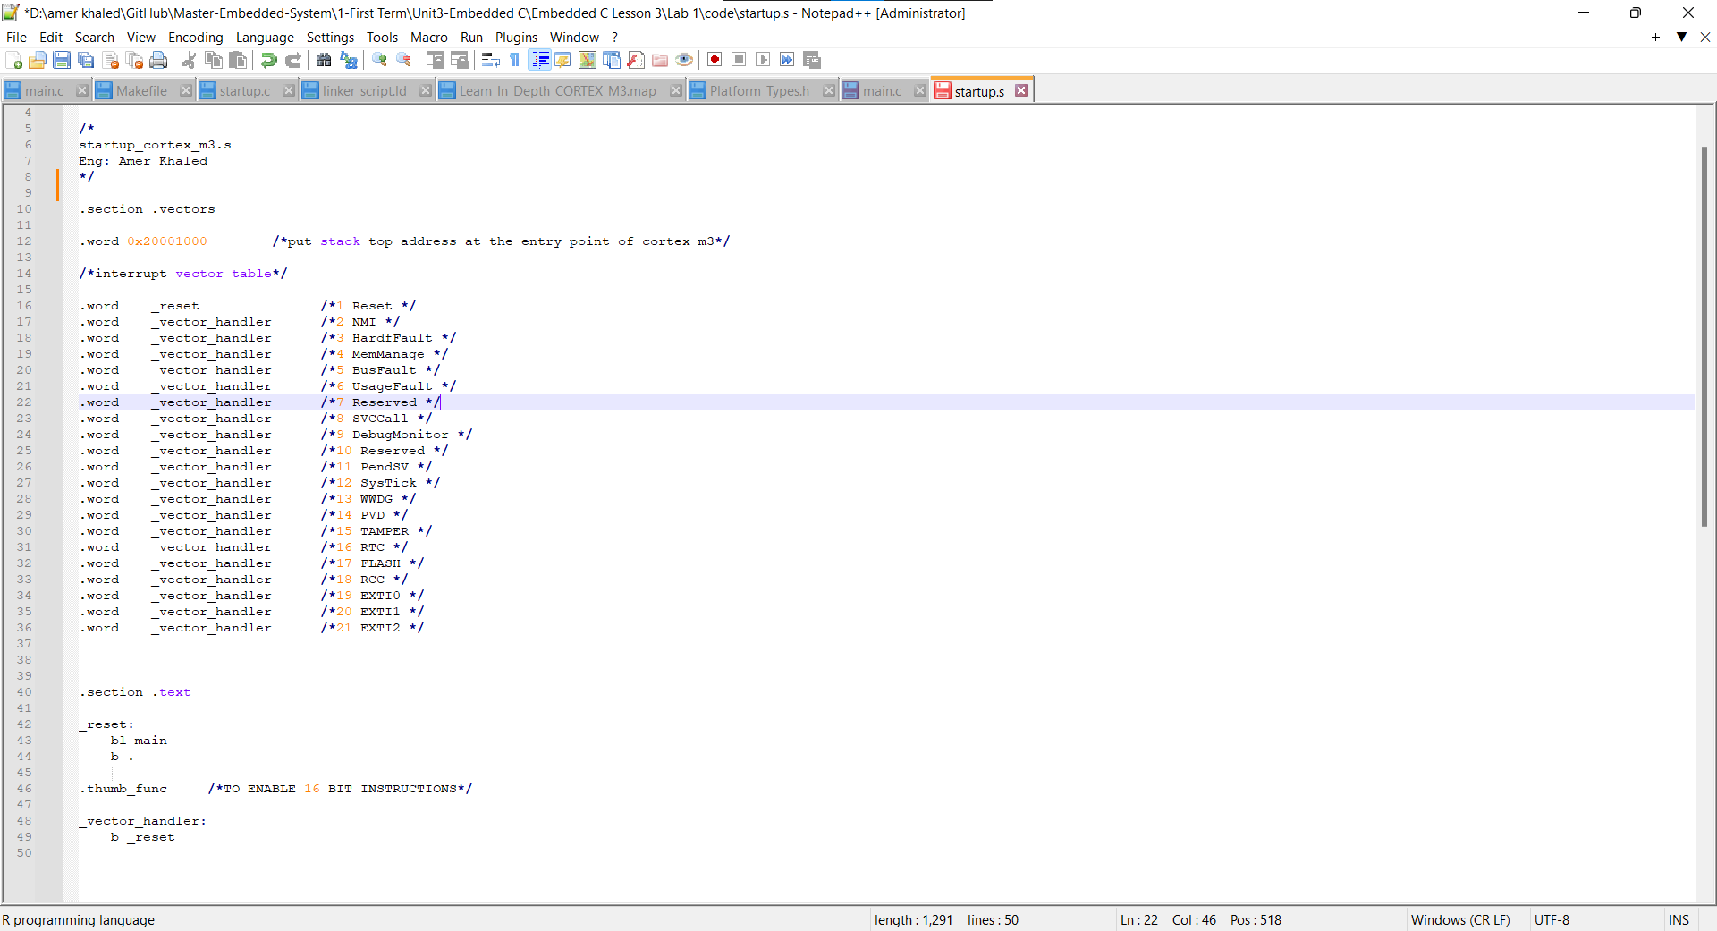

Linker_script.ld

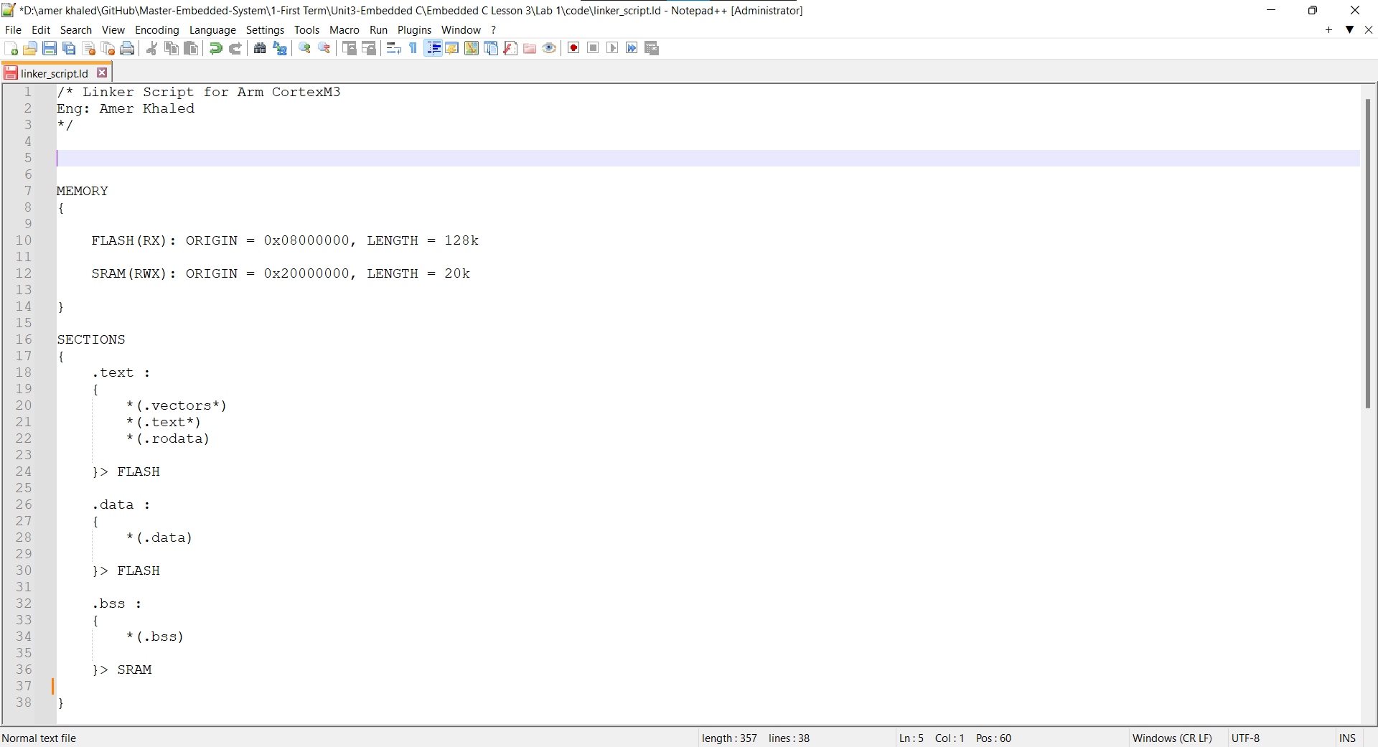

Makefile

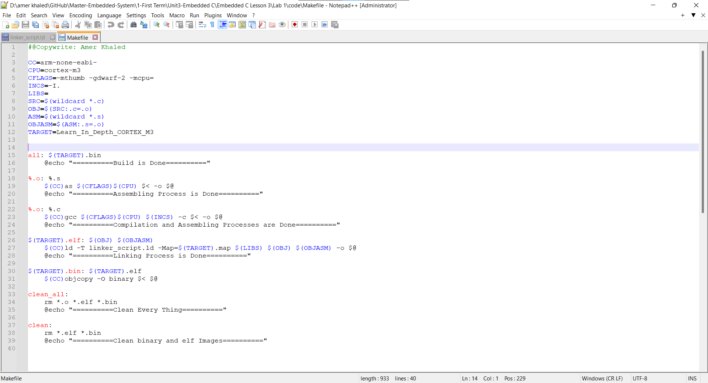

main.o: file format elf32-littlearm

Sections:

Idx Name Size VMA LMA File off Algn

0 .text 000000b0 00000000 00000000 00000034 2**2

CONTENTS, ALLOC, LOAD, RELOC, READONLY, CODE

1 .data 00000004 00000000 00000000 000000e4 2**2

CONTENTS, ALLOC, LOAD, DATA

2 .bss 00000000 00000000 00000000 000000e8 2**0

ALLOC

3 .debug_info 00000137 00000000 00000000 000000e8 2**0

CONTENTS, RELOC, READONLY, DEBUGGING

4 .debug_abbrev 000000cc 00000000 00000000 0000021f 2**0

CONTENTS, READONLY, DEBUGGING

5 .debug_loc 00000038 00000000 00000000 000002eb 2**0

CONTENTS, READONLY, DEBUGGING

6 .debug_aranges 00000020 00000000 00000000 00000323 2**0

CONTENTS, RELOC, READONLY, DEBUGGING

7 .debug_line 0000006b 00000000 00000000 00000343 2**0

CONTENTS, RELOC, READONLY, DEBUGGING

8 .debug_str 00000139 00000000 00000000 000003ae 2**0

CONTENTS, READONLY, DEBUGGING

9 .comment 00000012 00000000 00000000 000004e7 2**0

CONTENTS, READONLY

10 .ARM.attributes 00000033 00000000 00000000 000004f9 2**0

CONTENTS, READONLY

11 .debug_frame 0000002c 00000000 00000000 0000052c 2**2

CONTENTS, RELOC, READONLY, DEBUGGING

startup.o: file format elf32-littlearm

Sections:

Idx Name Size VMA LMA File off Algn

0 .text 00000008 00000000 00000000 00000034 2**1

CONTENTS, ALLOC, LOAD, RELOC, READONLY, CODE

1 .data 00000000 00000000 00000000 0000003c 2**0

CONTENTS, ALLOC, LOAD, DATA

2 .bss 00000000 00000000 00000000 0000003c 2**0

ALLOC

3 .vectors 00000058 00000000 00000000 0000003c 2**0

CONTENTS, RELOC, READONLY

4 .ARM.attributes 00000021 00000000 00000000 00000094 2**0

CONTENTS, READONLY

5 .debug_line 0000003b 00000000 00000000 000000b5 2**0

CONTENTS, RELOC, READONLY, DEBUGGING

6 .debug_info 0000009c 00000000 00000000 000000f0 2**0

CONTENTS, RELOC, READONLY, DEBUGGING

7 .debug_abbrev 00000014 00000000 00000000 0000018c 2**0

CONTENTS, READONLY, DEBUGGING

8 .debug_aranges 00000020 00000000 00000000 000001a0 2**3

CONTENTS, RELOC, READONLY, DEBUGGING

Learn_In_Depth_CORTEX_M3.elf: file format elf32-littlearm

Sections:

Idx Name Size VMA LMA File off Algn

0 .text 00000110 08000000 08000000 00008000 2**2

CONTENTS, ALLOC, LOAD, READONLY, CODE

1 .data 00000004 08000110 08000110 00008110 2**2

CONTENTS, ALLOC, LOAD, DATA

2 .debug_info 000001d3 00000000 00000000 00008114 2**0

CONTENTS, READONLY, DEBUGGING

3 .debug_abbrev 000000e0 00000000 00000000 000082e7 2**0

CONTENTS, READONLY, DEBUGGING

4 .debug_loc 00000038 00000000 00000000 000083c7 2**0

CONTENTS, READONLY, DEBUGGING

5 .debug_aranges 00000040 00000000 00000000 00008400 2**3

CONTENTS, READONLY, DEBUGGING

6 .debug_line 000000a6 00000000 00000000 00008440 2**0

CONTENTS, READONLY, DEBUGGING

7 .debug_str 00000118 00000000 00000000 000084e6 2**0

CONTENTS, READONLY, DEBUGGING

8 .comment 00000011 00000000 00000000 000085fe 2**0

CONTENTS, READONLY

9 .ARM.attributes 00000031 00000000 00000000 0000860f 2**0

CONTENTS, READONLY

10 .debug_frame 0000002c 00000000 00000000 00008640 2**2

CONTENTS, READONLY, DEBUGGING

Mapfile:

Memory Configuration

Name Origin Length Attributes

FLASH 0x08000000 0x00020000 xr

SRAM 0x20000000 0x00005000 xrw

*default* 0x00000000 0xffffffff

Linker script and memory map

.text 0x08000000 0x110

*(.vectors*)

.vectors 0x08000000 0x58 startup.o

*(.text*)

.text 0x08000058 0xb0 main.o

0x08000058 main

.text 0x08000108 0x8 startup.o

*(.rodata)

.glue_7 0x08000110 0x0

.glue_7 0x00000000 0x0 linker stubs

.glue_7t 0x08000110 0x0

.glue_7t 0x00000000 0x0 linker stubs

.vfp11_veneer 0x08000110 0x0

.vfp11_veneer 0x00000000 0x0 linker stubs

.v4_bx 0x08000110 0x0

.v4_bx 0x00000000 0x0 linker stubs

.iplt 0x08000110 0x0

.iplt 0x00000000 0x0 main.o

.rel.dyn 0x08000110 0x0

.rel.iplt 0x00000000 0x0 main.o

.data 0x08000110 0x4

*(.data)

.data 0x08000110 0x4 main.o

0x08000110 R_ODR

.data 0x08000114 0x0 startup.o

.igot.plt 0x08000114 0x0

.igot.plt 0x00000000 0x0 main.o

.bss 0x20000000 0x0

*(.bss)

.bss 0x20000000 0x0 main.o

.bss 0x20000000 0x0 startup.o

LOAD main.o

LOAD startup.o

OUTPUT(Learn_In_Depth_CORTEX_M3.elf elf32-littlearm)

.debug_info 0x00000000 0x1d3

.debug_info 0x00000000 0x137 main.o

.debug_info 0x00000137 0x9c startup.o

.debug_abbrev 0x00000000 0xe0

.debug_abbrev 0x00000000 0xcc main.o

.debug_abbrev 0x000000cc 0x14 startup.o

.debug_loc 0x00000000 0x38

.debug_loc 0x00000000 0x38 main.o

.debug_aranges 0x00000000 0x40

.debug_aranges

0x00000000 0x20 main.o

.debug_aranges

0x00000020 0x20 startup.o

.debug_line 0x00000000 0xa6

.debug_line 0x00000000 0x6b main.o

.debug_line 0x0000006b 0x3b startup.o

.debug_str 0x00000000 0x118

.debug_str 0x00000000 0x118 main.o

0x139 (size before relaxing)

.comment 0x00000000 0x11

.comment 0x00000000 0x11 main.o

0x12 (size before relaxing)

.ARM.attributes

0x00000000 0x31

.ARM.attributes

0x00000000 0x33 main.o

.ARM.attributes

0x00000033 0x21 startup.o

.debug_frame 0x00000000 0x2c

.debug_frame 0x00000000 0x2c main.o

